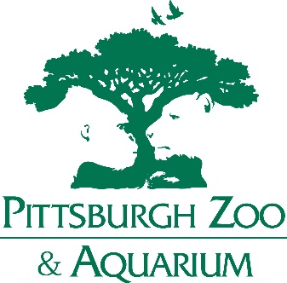

Dear ZRA Members,
We are delighted to announce that the 2026 ZRA Annual Conference will be hosted by Heather Terrell and the Pittsburgh Zoo & Aquarium!
October 12-17, 2026
Located just minutes from downtown Pittsburgh, the Pittsburgh Zoo & Aquarium is home to over 8,000 animals representing more than 600 species. From its expansive African Savanna to the immersive Tropical Forest and the stunning Water’s Edge, the zoo provides a memorable setting that combines conservation, education, and innovation. Attendees will also get the rare chance to explore the zoo’s unique Aquarium, one of only a few major zoo-aquarium combinations in the country.
Beyond the zoo, Pittsburgh itself is a city full of history, culture, and charm. Known as the “City of Bridges,” Pittsburgh is celebrated for its beautiful skyline, world-class museums, and vibrant neighborhoods. Visitors can explore the Andy Warhol Museum, take in breathtaking views from the Duquesne Incline, stroll through the Phipps Conservatory and Botanical Gardens, or catch a game in this sports-loving city. With a thriving restaurant scene and plenty of opportunities to experience the city’s rich history, there will be no shortage of things to do outside conference hours.
We are grateful to Heather and the Pittsburgh Zoo & Aquarium team for their hospitality and enthusiasm in hosting the 2026 conference. More details, including dates, hotel information, and program highlights, will be shared as planning continues.
Mark your calendars, we can’t wait to welcome you to Pittsburgh for another inspiring ZRA Annual Conference!
Joann Watson
Annual Conference Chair

